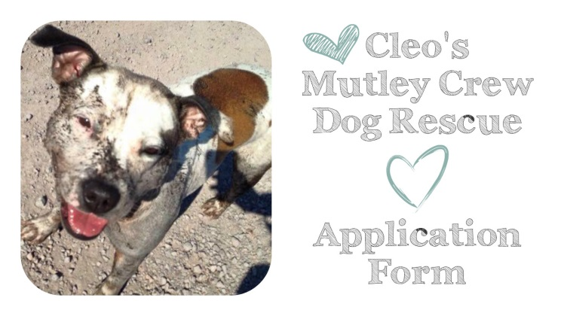
PLEASE RETURN COMPETED FORMS TO CLEOSMUTLEYCREW@GMAIL.COM
PLEASE READ THE FORM CAREFULLY AS THIS WILL HELP US DETERMINE IF YOU ARE A SUITABLE MATCH FOR THE DOG YOU ARE INTERESTED IN.
PLEASE UNDERSTAND WE MAY SUGGEST A DIFFERENT DOG IF WE FEEL YOU ARE BETTER SUITED TO ANOTHER DOG THAN THE ONE YOU ARE APPLYING FOR.
PLEASE ANSWER ALL QUESTIONS AND GIVE AS MUCH DETAIL AS POSSIBLE, IF A QUESTIONS DOES NOT APPLY TO YOU THEN PLEASE MARK WITH N/A. YES OR NO QUESTIONS CAN BE MARKED WITH A (Y) FOR YES AND (N) FOR NO.

DOG YOU ARE APPLYING FOR:

PERSONAL DETAILS
FULL NAME: |  |  | D.O.B:
ADDRESS:
EMAIL: |  | CONTACT NUMBER:
OCCUPATION: |  | PART/FULL TIME:

HOME LIFESTYLE
TYPE OF PROPERTY YOU LIVE IN? (flat, detached, terraced etc.)
OWNED OR RENTED? (if rented, do you have permission to keep pets?)
DO YOU HAVE A GARDEN? (is it shared or private, is it secure?)
PLEASE GIVE DETAILS OF ALL PERSONS LIVING AT THIS ADDRESS INCLUDING AGES
DO YOU DRIVE OR HAVE ACCESS TO TRANSPORT?
HOW LONG PER DAY WOULD A DOG BE LEFT ALONE?
HOW ACTIVE IS YOUR LIFESTYLE?

CURRENT & PREVIOUS PETS
DO YOU HAVE ANY OTHER PETS? (please specify species, breed, sex & age of pets)

ARE YOUR CURRENT PETS SPAYED/NEUTERED? (If not, why?)

ARE YOUR PETS UP TO DATE WITH VACCINATIONS, FLEA AND WORMING?
DOES YOUR CURRENT DOG(S) SOCIALISE WITH OTHER DOGS ON A REGULAR BASIS?
HOW SOCIABLE IS YOUR CURRENT DOG WITH OTHER DOGS?
WHAT IS YOUR CURRENT DAILY WALKING ROUTINE?
CURRENT VET PRACTICE:

WHAT PREVIOUS DOGS HAVE YOU OWNED?

HAVE YOU EVER HAD TO GIVE A DOG UP? (If yes, why?)

EXPERIENCE
HAVE YOU EVER ADOPTED BEFORE? (if yes, please give details)

WHAT TYPE OF BEHAVIOURS HAVE YOU DEALT WITH BEFORE?
HOW WOULD YOU DEAL WITH A DOG HAVING A TOILET ACCIDENT IN YOUR HOME?

HOW WOULD YOU DEAL WITH A DOING BEING DESTRUCTIVE IN YOUR HOME?

HOW WOULD YOU DEAL WITH A DOG THAT HAS SEPARATION ANXIETY?

DO YOU FEEL YOU COULD CONTROL A DOMINATING DOG?

HOW WOULD YOU DEAL WITH AN ADOPTED DOG THAT DIDN’T GET ALONG WITH YOUR CURRENT DOG?

HOW MUCH TIME ARE YOU WILLING TO GIVE YOUR ADOPTED DOG TO SETTLE IN?

ARE YOU WILLING TO WORK THROUGH ANY HARDSHIPS WITH YOUR ADOPTIVE DOG WITH HELP FROM OUR TRAINER OR AN EXPERIENCED FOSTERER?

ADOPTION PREFERANCES
WHY DO YOU WANT TO ADOPT?

WOULD YOU ADOPT ANY BREED OF DOG?
HOW MUCH EXERCISE ARE YOU WILLING TO GIVE YOUR ADOPTED DOG?

IS THERE ANY ISSUES YOU FEEL YOU COULD NOT COPE WITH?

PLEASE USE THIS SECTION TO ADD ANY REVELANT INFORMATION ABOUT YOURSELF, FAMILY AND LIFESTYLE THAT YOU FEEL MAY SUPPORT YOUR APPLICATION:

ADOPTION FEE
We do not give away free dogs nor do we sell any dogs to make profit. We are a non-profit rescue organisation that survives on donations from our supporters and the public. We also organise fund-raisers and events to raise funds for the dogs, without funds there would be no rescue.

WHY IS THERE AN ADOPTION FEE?
Our dogs are not for sale nor are they free; we require a fixed sum donation to the rescue on the adoption of your dog.
Why? All of our dogs are neutered, vaccinated, micro chipped, deflead and wormed prior to being adopted. This is not free and we have to pay our vets for these procedures. Our dogs also receive and other medical treatment or operations that may be required.
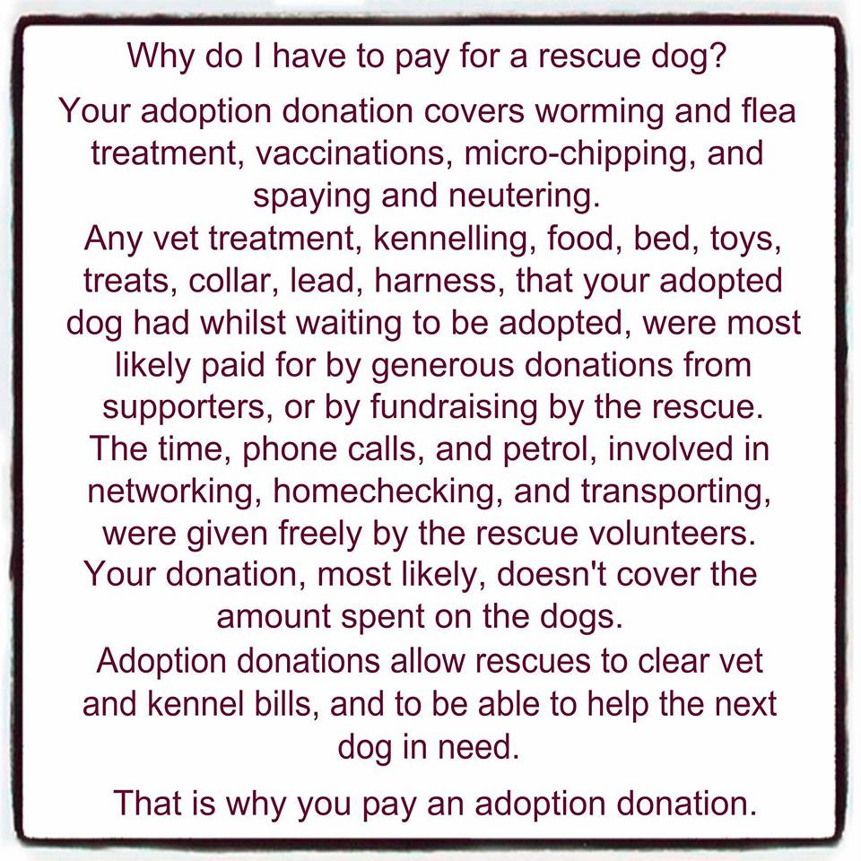
WHAT IS THE ADOPTION FEE?
OUR ADOPTION FEE IS £170
This must be paid before the adoption can be finalised, therefore we remain the owners of all our dogs and all details including microchip are registered to the rescue until your adoption fee has been paid the paperwork finalised.
Failure to pay the adoption fee could result in the following
- Removal of our dog from your property
- If force is required the police will be contacted
- If no contact can be made and we cannot access your property the dog may be reported as stolen

HOW TO PAY THE ADOPTION FEE?
Before your dog arrives on home trial a £70 deposit will be required. This will only be returned if the dog is returned to the rescue due to exceptional circumstances during the 14 day home trial period only, otherwise this deposit is non-refundable and retained by the rescue.
If you decide to return the dog to the rescue after the 14 day home trial, your deposit will not be refunded.
If you decide to go ahead with the adoption the £70 is added to the total adoption fee and you will be asked to pay the remainder of the adoption fee of £100
PUPPIES UNDER 6 MONTHS OLD
Puppies under the age of 6 months old do not require a home trial therefore the full adoption fee of £170 must be paid in full on day of adoption.
Do you understand and agree to the Adoption Fee Process?
Do you agree to pay £70 deposit on commencement of your home trial? (excludes puppies under 6 months old)

PLEASE DO NOT APPLY TO ADOPT IF YOU ARE NOT IN A POSITION TO HONOUR THE ADOPTION FEE

Sign:

Date:

