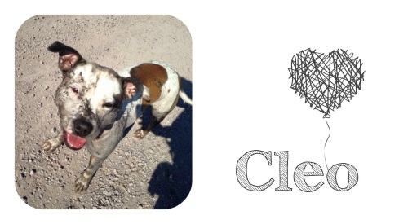
Cleo’s Mutley Crew Dog Rescue
Sponsor A Kennel Membership Form

FULL NAME:

ADDRESS:

EMAIL:

CONTACT NO:

MEMBERSHIP LEVEL: (bronze, silver or gold)

PAYMENT METHOD: (direct debit or monthly PayPal subscription)

NAME AS IT APPEARS ON YOUR ACCOUNT:

Monthly payments can be set up via direct debit or monthly PayPal subscription, please ask for details.

Sign:

Date:

