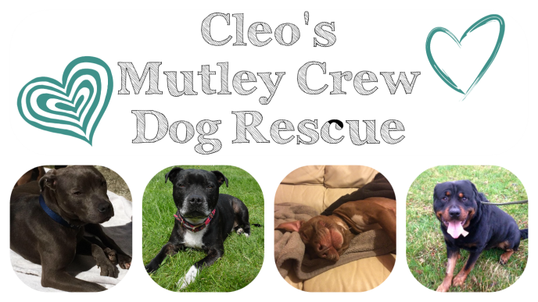
Please carefully read the job description spec and the application form before completing.
Job Description
All positions stated here are completely voluntary, we cannot offer any form of paid work.
FUND-RAISING
With the help of our Fund-raising Coordinator, you will be responsible for organising and helping with projects and events that will raise funds for the rescue.
You will work as part of team to arrange events, auctions and much more.
Guidance will be given and full support will always be available.

EVENTS
As part of a team you will be responsible for liaising with the public at CMC events.
Volunteers are required at events to help out on stalls, bag-packing, give out information, promote the rescue and handle the dogs.
Guidance will be given and full support will always be available.

HOME-CHECKING
You will be responsible for inspecting the homes of potential adopters and fosters and completing home check forms and submitting back to the rescue coordinator.
Inexperienced home-checkers will be required to shadow one of our more experienced home-check volunteers, as always full support & training if required will always be available.
Dog handling &Driving is essential

DOG-TAXI
You will be responsible for transporting supplies between locations as well as transporting dogs to and from - foster homes, kennels, vets appointments, meet and greets & events.
You must be able to transport a dog safely in your car by a crate, boot guard or seat belt.
Dog handling & Driving is essential

Social Media
You will be responsible for sharing our posts far and wide as much as possible on Facebook, Twitter, Instagram etc., and promoting the rescue online.
Full support will always be available

Page Admin/Moderator
This is a customer service like post, you will be responsible for maintain our Facebook page, sharing posts, replying to messages, updating information, sending application forms etc. You must be well mannered and polite.
Full support and training will be given

Volunteer Application Form

PERSONAL DETAILS
FULL NAME
D.O.B
EMAIL ADDRESS
CONTACT NUMBER
FULL ADDRESS
OCCUPATION/HOURS WORKED
DO YOU HOLD A DRIVERS LICENCE?
DO YOU HAVE ACCESS TO VEHICLE?
DO YOU HAVE REGULAR ACCESS TO A LAPTOP, TABLET etc.?
EXPERIENCE
WHAT EXPERIENCE DO YOU HAVE WITH DOGS?
HAVE YOU EVER VOLUNTEERED WITH A RESCUE BEFORE?
HOW EXPERIENCED ARE YOU WITH SOCIAL MEDIA?

VOLUNTEERING
Please answer yes or no below the following options regarding which area you would like to volunteer
FUND-RAISING | EVENTS | HOMECHECKING | DOG TAXI | SOCIAL MEDIA | PAGE ADMIN | FOSTERING

WHY DO YOU WANT TO VOLUNTEER?
WHEN CAN YOU BEGIN VOLUNTEERING?
HOW MUCH TIME CAN YOU COMMIT?
ARE YOU WILLING TO MAKE PHONE CALLS ON THE RESCUE’S BEHALF?
ARE YOU WILLING TO UNDERGO ANY TRAINING?
ARE YOU WILLING TO ATTEND ANY EVENTS?
ARE YOU ABLE TO SHARE OUR SOCIAL MEDIA POSTS?

TELL US ABOUT YOURSELF –

DO YOU FEEL THERE IS ANYTHING YOU CAN BRING TO THE RESCUE THAT IS NOT ALREADY MENTIONED ABOVE?

RESCUE VOLUNTEER WAIVER AGREEMENT
Please read the following statements carefully as you will be required to adhere by these at all times if selected to become a volunteer
- I understand that if I become a volunteer for CMC, I am representing a non-profit organisation when doing volunteer work for CMC and will conduct myself in an appropriate manner.
- I shall not profit in anyway, by any activity as a CMC volunteer.
- I understand that it is my decision to volunteer for CMC and I will not hold CMC, nor any of its members, liable for any damage, injury or harm caused directly or indirectly through my volunteer activities with CMC.
- I understand that as an individual, I cannot enter into any agreements for the rescue organisation; any such activity will be forwarded to the appropriate coordinator.
- I understand that CMC cannot guarantee or be held responsible for the health, behaviour or temperament of any rescue dog I may handle. I am aware that rescue dogs may cause personal or property damage and agree to keep any rescue dog safe and securely contained.
- I understand that as a CMC volunteer I may have to handle sensitive and confidential data while conducting my volunteer activities. I shall not discuss any such data with anyone other than a CMC coordinator and will not share any such data with irrelevant parties. I agree to adhere to the data protection act.
Do you agree to adhere to the above waiver conditions?

Sign –
Date -

PLEASE RETURN ALL COMPLETED FORMS TO
miss.debs87@gmail.com

